Clean Code Principles - Use Meaningful Names
# Source: AI Source: Provided by: [Data Path: Persons Table -> ID Column: 1, Name_En Column: Motasem Essam] -> From: [Chatgpt (GPT‑5 Mini)] on [12/9/2025]
One of the most important principles of clean code is choosing names that clearly express intent and purpose. Good names make your code easier to read, understand, and maintain—without needing extra explanation.

🔑 Why Meaningful Names Matter
# Source: AI Source: Provided by: [Data Path: Persons Table -> ID Column: 1, Name_En Column: Motasem Essam] -> From: [Chatgpt (GPT‑5 Mini)] on [12/9/2025]
- Code is read more often than it is written
- Clear names reduce the need for comments
- Improves collaboration with other developers
- Makes debugging and refactoring easier

✅ Good Naming Guidelines

1. Be Descriptive and Specific
# Source: AI Source: Provided by: [Data Path: Persons Table -> ID Column: 1, Name_En Column: Motasem Essam] -> From: [Chatgpt (GPT‑5 Mini)] on [12/9/2025]
Names should tell exactly what something represents or does.
❌ Bad:
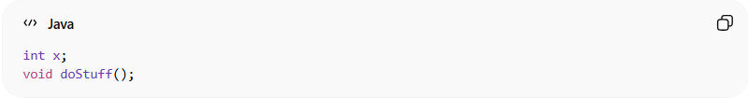
int x;
void doStuff();
✔️ Good:
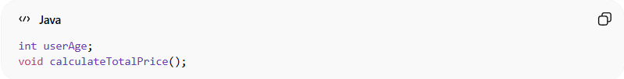
int userAge;
void calculateTotalPrice();

2. Use Intent-Revealing Names
# Source: AI Source: Provided by: [Data Path: Persons Table -> ID Column: 1, Name_En Column: Motasem Essam] -> From: [Chatgpt (GPT‑5 Mini)] on [12/9/2025]
The name should answer: Why does this exist? What does it do?
❌ Bad:
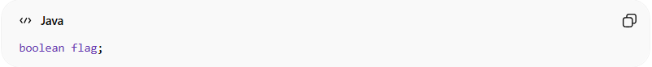
boolean flag;
✔️ Good:
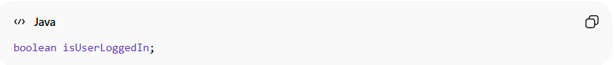
boolean isUserLoggedIn;

3. Avoid Abbreviations
# Source: AI Source: Provided by: [Data Path: Persons Table -> ID Column: 1, Name_En Column: Motasem Essam] -> From: [Chatgpt (GPT‑5 Mini)] on [12/9/2025]
Abbreviations make code harder to read.
❌ Bad:
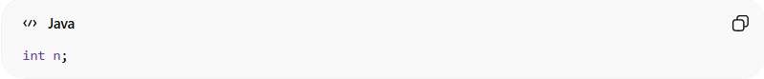
int n;
✔️ Good:
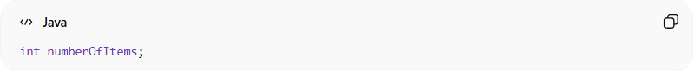
int numberOfItems;

4. Use Consistent Naming
# Source: AI Source: Provided by: [Data Path: Persons Table -> ID Column: 1, Name_En Column: Motasem Essam] -> From: [Chatgpt (GPT‑5 Mini)] on [12/9/2025]
Stick to a consistent style across your codebase.
❌ Bad:
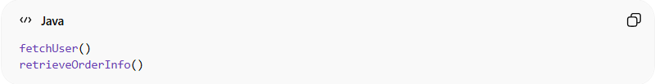
fetchUser()
retrieveOrderInfo()
✔️ Good:
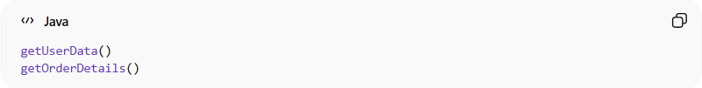
getUserData()
getOrderDetails()

5. Use Pronounceable and Searchable Names
# Source: AI Source: Provided by: [Data Path: Persons Table -> ID Column: 1, Name_En Column: Motasem Essam] -> From: [Chatgpt (GPT‑5 Mini)] on [12/9/2025]
Names should be easy to say and find in the codebase.
❌ Bad:
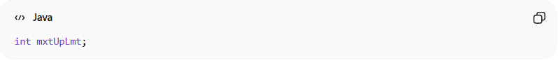
int mxtUpLmt;
✔️ Good:
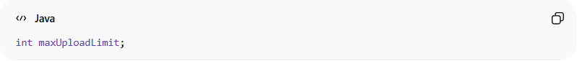
int maxUploadLimit;

6. Avoid Noise Words
# Source: AI Source: Provided by: [Data Path: Persons Table -> ID Column: 1, Name_En Column: Motasem Essam] -> From: [Chatgpt (GPT‑5 Mini)] on [12/9/2025]
Words like data, info, manager, handler are often meaningless.
❌ Bad:
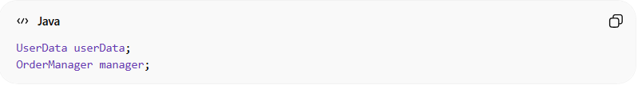
UserData userData;
OrderManager manager;
✔️ Better:
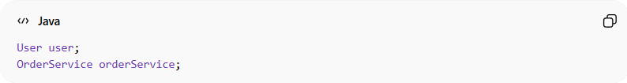
User user;
OrderService orderService;

7. Use Domain-Specific Terms
# Source: AI Source: Provided by: [Data Path: Persons Table -> ID Column: 1, Name_En Column: Motasem Essam] -> From: [Chatgpt (GPT‑5 Mini)] on [12/9/2025]
Use names that match the business or domain language.
❌ Bad:
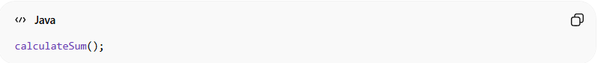
calculateSum();
✔️ Good:
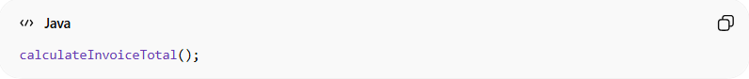
calculateInvoiceTotal();

8. Name Functions by What They Do
# Source: AI Source: Provided by: [Data Path: Persons Table -> ID Column: 1, Name_En Column: Motasem Essam] -> From: [Chatgpt (GPT‑5 Mini)] on [12/9/2025]
Function names should be verbs.
❌ Bad:
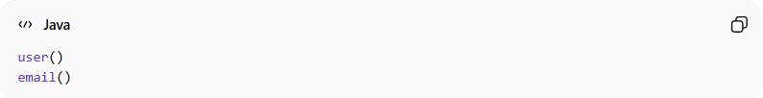
user()
email()
✔️ Good:
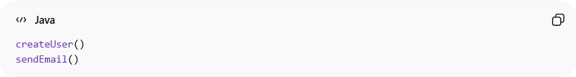
createUser()
sendEmail()

9. Name Variables by What They Represent
# Source: AI Source: Provided by: [Data Path: Persons Table -> ID Column: 1, Name_En Column: Motasem Essam] -> From: [Chatgpt (GPT‑5 Mini)] on [12/9/2025]
Variables should be nouns.
❌ Bad:
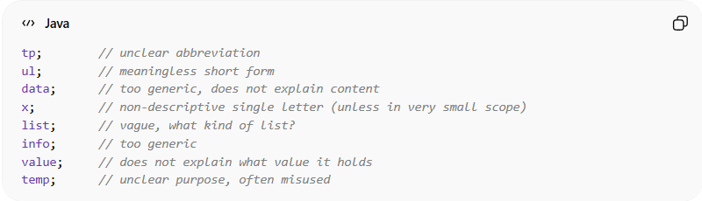
tp; // unclear abbreviation
ul; // meaningless short form
data; // too generic, does not explain content
x; // non-descriptive single letter (unless in very small scope)
list; // vague, what kind of list?
info; // too generic
value; // does not explain what value it holds
temp; // unclear purpose, often misused
✔️ Good:
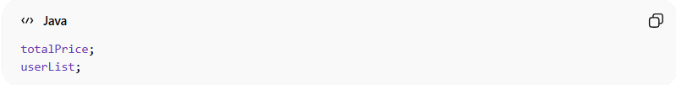
totalPrice;
userList;

🚫 Common Mistakes to Avoid
# Source: AI Source: Provided by: [Data Path: Persons Table -> ID Column: 1, Name_En Column: Motasem Essam] -> From: [Chatgpt (GPT‑5 Mini)] on [12/9/2025]
- Single-letter names (x, y, i) except in very small scopes (like loops)
- Vague names (data, value, temp)
- Misleading names that don’t match behavior
- Overly long or complex names

💡 Rule of Thumb
# Source: AI Source: Provided by: [Data Path: Persons Table -> ID Column: 1, Name_En Column: Motasem Essam] -> From: [Chatgpt (GPT‑5 Mini)] on [12/9/2025]
If a name needs a comment to explain it, the name is probably bad.

🧾 Summary
# Source: AI Source: Provided by: [Data Path: Persons Table -> ID Column: 1, Name_En Column: Motasem Essam] -> From: [Chatgpt (GPT‑5 Mini)] on [12/9/2025]
Meaningful names are the foundation of clean code. They make your code:
- Self-explanatory
- Easier to maintain
- Easier to debug
- Easier for teams to collaborate on

